Periodical Cost Allocation Check Box – C0580

|  |  |  |  |  |
| --- | --- | --- | --- | --- |
| **Ver** | **Date** | **Author** | **Comments** | **Reviewed by** |
| 1 | 16/02/2020 | Tom Bell | CRIM 580 | TBC |
|  |  |  |  |  |

Requirements 2

Prerequisites 2

Solution Overview 2

Solution Details 2

Security 3

Companies 3

Data Migration 3

Test Steps 3

Technical Implementation 3

Requirements

A column containing checkboxes is required on the GL Voucher Rows Analysis screen, GL Voucher Details Analysis screen and Voucher Rows Analysis screen. If the underlying transaction has Period Allocation as ”Y” then the checkbox will be ticked, if not the checkbox will be false.

Prerequisites

<Describe any pre-requisites that this development may rely upon, data configuration or other developments>

Solution Overview

An additional column is required on the following screens:

* Financials > General Ledger > GL Voucher Rows Analysis screen
* Financials > General Ledger > GL Voucher Details Analysis screen
* Accounting Rules > Voucher > Analysis > Voucher Rows Analysis screen

The additional column should be called “Period Allocation” and the field should contain a check box.

* IF the “Period Allocation” field contains “Y” then the checkbox must be TRUE.
* IF the “Period Allocation” field contains “N” then the checkbox must be FALSE.

The below table shows where the data can be found.

|  |  |  |
| --- | --- | --- |
| **Data Source Screen** | **Data Source Field** | **Target Column Screen** |
| Accounting Rules > Voucher > Analysis > Voucher Details Analysis screen | Requires the data from the same source as the below screen through a join.   * Voucher_Type * Voucher_No * Row_No   From the Voucher_Rows table | Financials > General Ledger > GL Voucher Rows Analysis screen  &  Financials > General Ledger > GL Voucher Details Analysis screen |
| Accounting Rules > Voucher > Analysis > Voucher Details Analysis screen | Period Allocation | Accounting Rules > Voucher > Analysis > Voucher Rows Analysis screen |

Solution Details

A column called Period Allocation must be available in the following screens.

* **Financials > General Ledger > GL Voucher Rows Analysis**

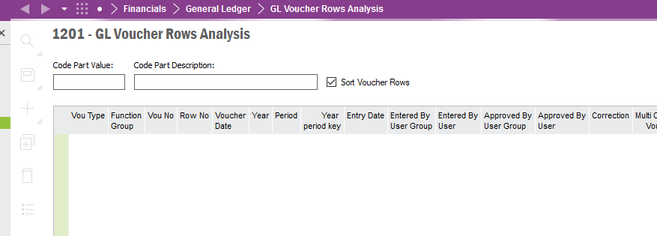

* **Financials > General Ledger > GL Voucher Details Analysis.**

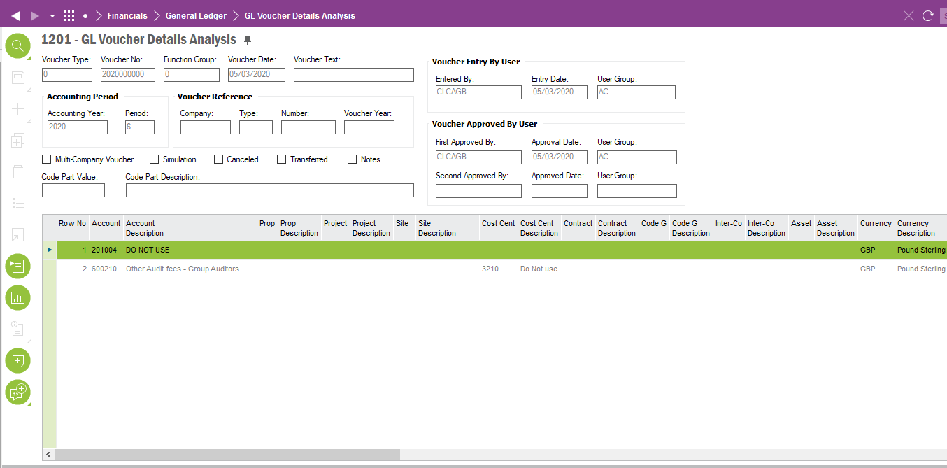

* **Accounting Rules > Voucher > Analysis > Voucher Rows Analysis**

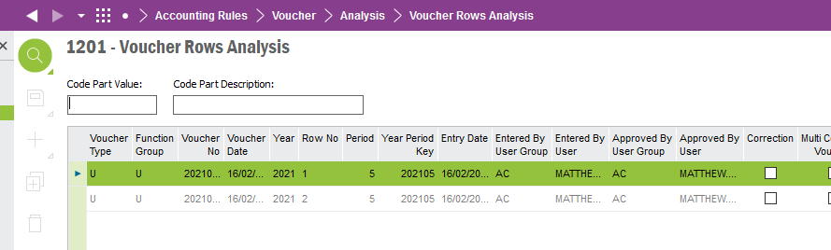

The next section will detail where the field’s data source is located.

# Voucher Details Analysis

The below screenshot shows the data source for the Period Cost Allocation field. It is in this screen where the “Period Allocation” field must come from. The checkbox must correspond to the;

**Voucher Type, Voucher No. and Row Number.**

The below screenshot shows where this column must be located.



The below screenshot shows the “Period Allocation” marked in red is the field in the Voucher Detail Analysis screen. This is the field that must be shown on the Voucher Rows Analysis screen.

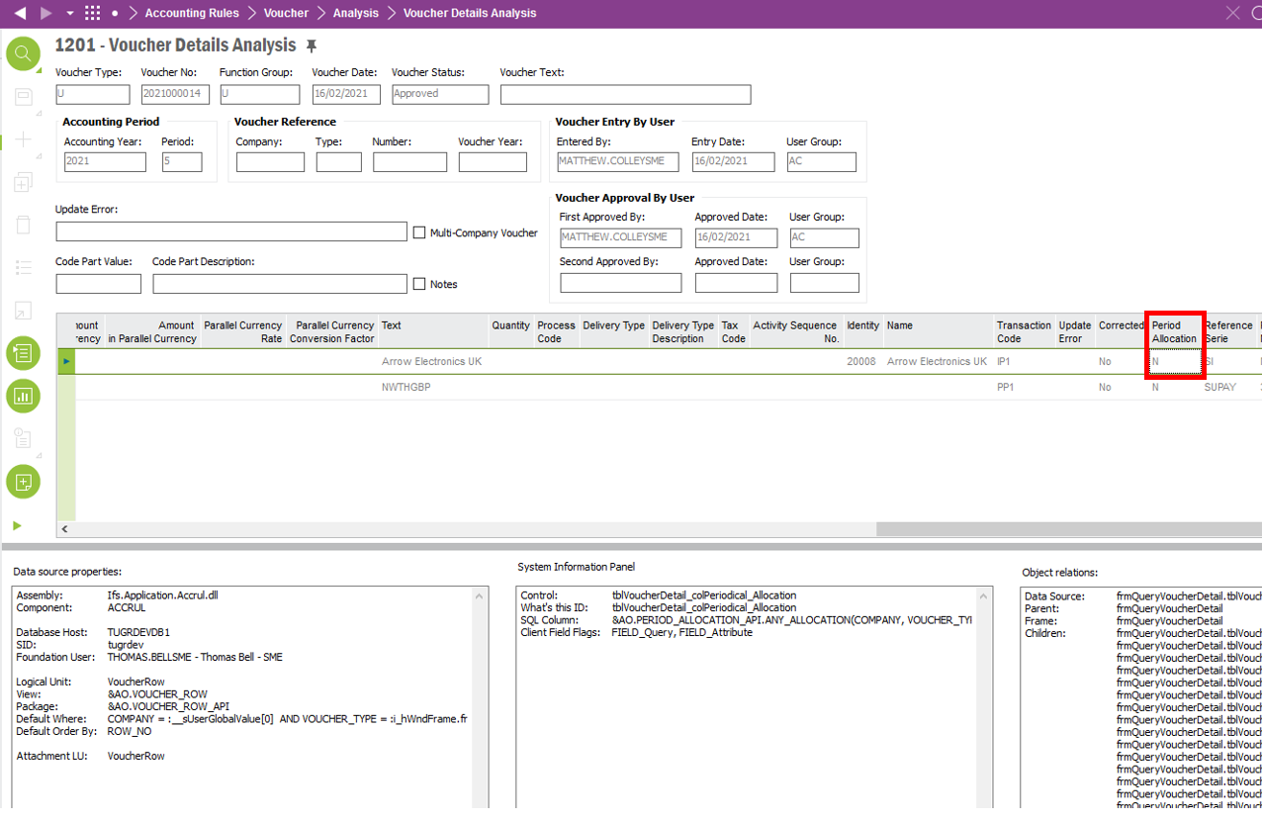

# GL Voucher Rows Analysis

The Period Cost Allocation field isn’t located on the GL Row Voucher Details Analysis screen. It must be pulled by joining the Voucher Rows table (the field and screen can be seen in the section above). Below is an overview of the logic.

The column logic in this screen must select the “Period_Allocation” field into the GL Voucher Rows Analysis screen using the below fields from the Voucher Row table.

Select Period_Allocation where the below fields from Voucher_Row table = the fields in the “GL Voucher Row Analysis”

* Voucher_Type
* Voucher_No
* Row_No

The below screenshot shows where this column must be located.



# GL Voucher Details Analysis

The above logic needs to be applied within the GL Voucher Details Analysis view as well. The below screenshot shows where this column must be located.



# Voucher_Row table and Period_Allocation column location

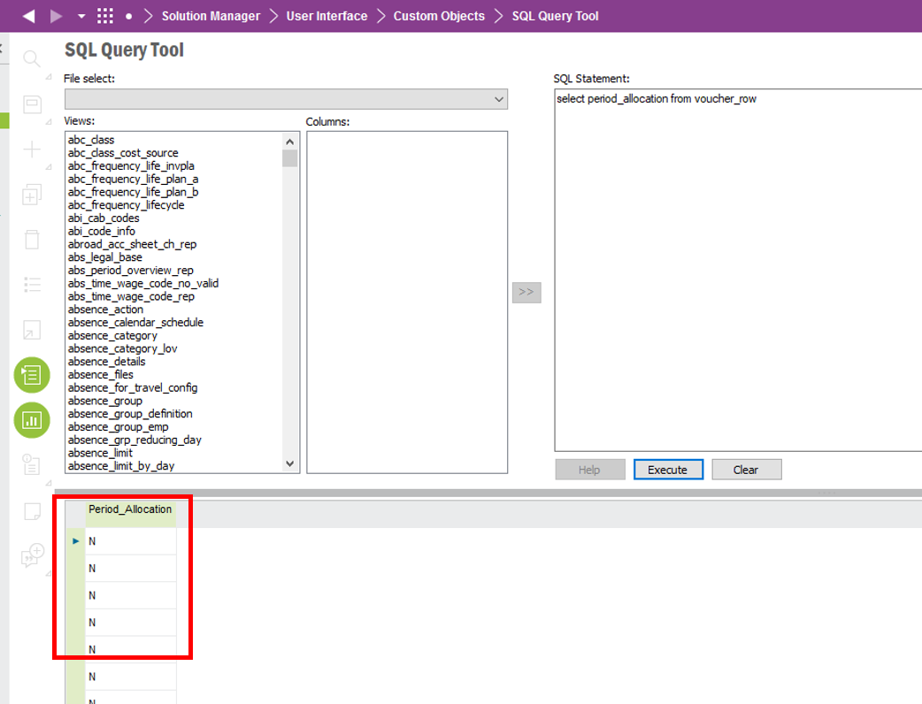

**Technical.**

Field Definitions.

<New Field/CLU Definition>

|  |  |  |  |  |  |  |
| --- | --- | --- | --- | --- | --- | --- |
| New DB Object Name | DB Object Item/Field Names | Item Description | Item Data Type | Item Syntax | Calculation Spec, if Derived | LOVs/Enums/Is Mandatory? |
|  |  |  |  |  |  |  |
|  |  |  |  |  |  |  |
|  |  |  |  |  |  |  |
|  |  |  |  |  |  |  |
|  |  |  |  |  |  |  |
|  |  |  |  |  |  |  |
|  |  |  |  |  |  |  |
|  |  |  |  |  |  |  |
|  |  |  |  |  |  |  |
|  |  |  |  |  |  |  |
|  |  |  |  |  |  |  |
|  |  |  |  |  |  |  |

Security

<Define security controls> (Who needs access to this and will it be restricted from any other users etc)

Companies

Applies to the following companies. All.

|  |  |
| --- | --- |
| **Company** | **Required (Y/N)** |
| 1201 | Y |
| TBC |  |
|  |  |

Data Migration

<Describe any data migration impacts this development may have – i.e additional data to be migrated>

Test Steps

<Steps that needs to be taken to test this change. Please provide expected results> Updated post solution.

|  |  |  |
| --- | --- | --- |
| **No** | **Script\Test Steps** | **Expected Result** |
| 1 |  |  |
| 2 |  |  |
|  |  |  |
|  |  |  |

Technical Implementation

<Completed by the technical developer - Technical solution, list packages, functions, Custom menus created etc >

Package

**EA_FINANCE**

Permissions Granted

**IFS_ALL**

**Custom Fields**

1. **GL Voucher Rows Analysis**

NOTE - If the Period Allocation Column is not available in the layout. RMB on the column headers, Column Chooser, add the period allocation column.

If the column is not available in the column chooser, check for the following custom field. Make sure it is approved, published and synchronized.

Also, publish the following view in the same logical Unit.

1. **GL Voucher Details Analysis**

NOTE - If the Period Allocation Column is not available in the layout. RMB on the column headers, Column Chooser, add the period allocation column.

1. **Voucher Rows Analysis**

NOTE - If the Period Allocation Column is not available in the layout. RMB on the column headers, Column Chooser, add the period allocation column.

If the column is not available in the column chooser, make sure to check for the following custom field.

Also, publish the following view in the same logical Unit.

**Custom Logical Unit**

NOTE – Make sure the following custom LU is approved, published and synchronized.

**Custom Events**

The following custom event and custom event action needs to be enabled.

**Custom Enumeration**

